Carlos Ariceaga 6th
Marcus DeSieno
“A Photograph of the Crab Nebula Eaten by Bacteria Found on a Table at a Red Lobster Restaurant”
This photo is what the title says. I like this photo because of the different colors clashing together.
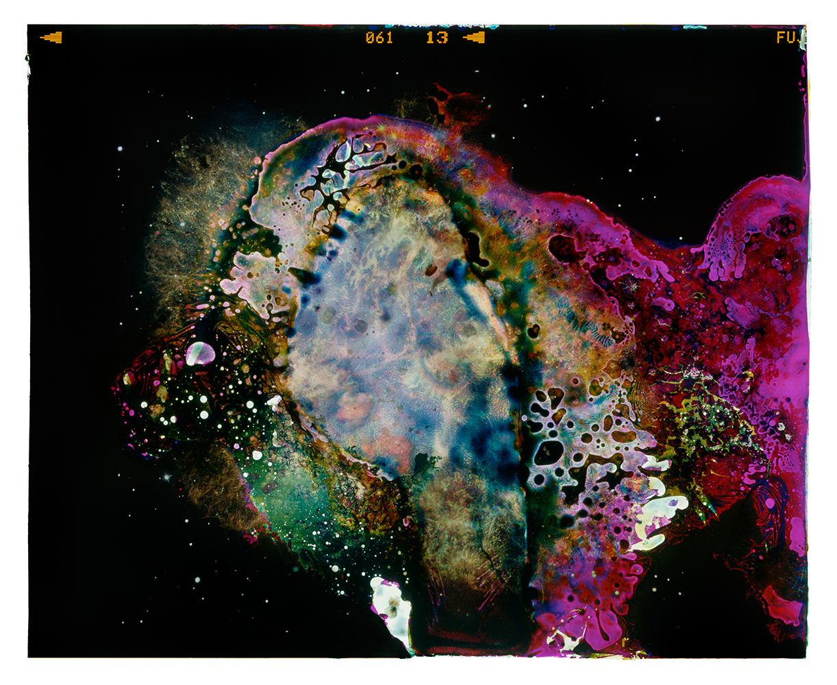
I believe this photograph is telling us that we can find creative colorful things that we do not expect. I believe the photographer can be creative and thinks outside the box and finds different things no one expects to find.

ALYSSA SALOMON UNTITLED
This photograph is a picture of birds with chemicals on the photo. I like this photo because it’s not anything too grand. It’s simple and good. I think this photo can show the simplicity of anything in the world. This shows how the photographer looks at the simple things in life.
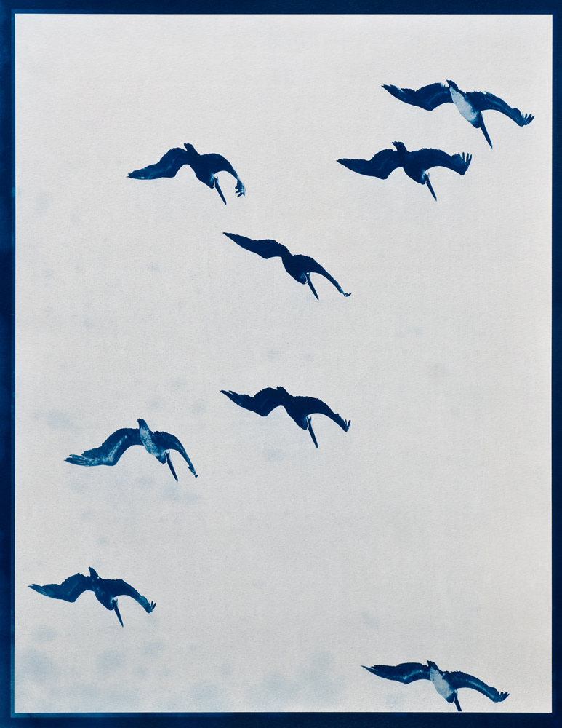

THOMAS JACKSON “Cheeseballs”
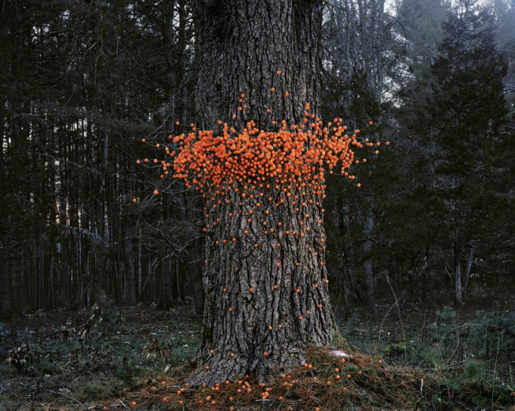
This photo is a picture of a tree with cheeseballs around it. I like this picture because I am hungry and I am now craving these. This can show how the nature of the world can be interlocked with the creation of us. I think the photographer is creative for trying to show us the relationship of these two different things.

